# File Maker Documentation

## July 17th meeting

1. New “Application Status” field separate from appointment status
   1. On entry it is pending
   2. After review: complete/valid (wording still being finalized)
   3. If it never goes to DAG: Ineligible / Program Decline / Non – DAG Decline (name to be chosen to avoid confusion with DAG declines)
   4. If it proceeds to DAG: DAG revie / Consideration (then DAG Approved or DAG Declined)?
   5. Terminology at this step still unsure? However should have clear distinction from Application status terminology and appointment terminology
2. Existing Appointment Status ( current/expired/revoked/rescinded box)
   1. Tied to effective/expiry dates and post-approval changes
3. Summary Report Constraints
   1. Currently, the summary report sent to the DAG is only generated when the records are marked as “approved” and an effective date is entered? (My understanding)
   2. OIC team wants to be able to generate this report earlier (eg, on ready / recommended status) and then mass-update outcomes after the briefing note returns.
   3. Mass “select all / update” is desired. However, this was mentioned to be a Shane task

## Commissioners Summary Report / DAG briefing Note Emails

1. DAG Briefing Note (DBN?) comes back with either Y/N, the only changes it comes back with are a signature / date:
   1. Y – all recommendation approved, listing the total number of approvals, date

and appointment Order #’s for approvals, and total number of declines.

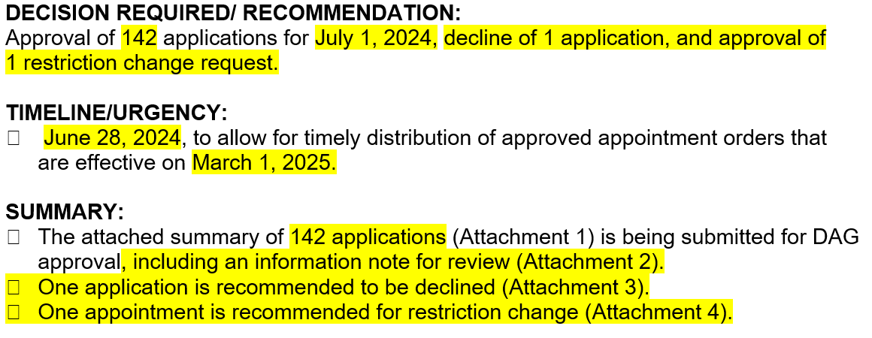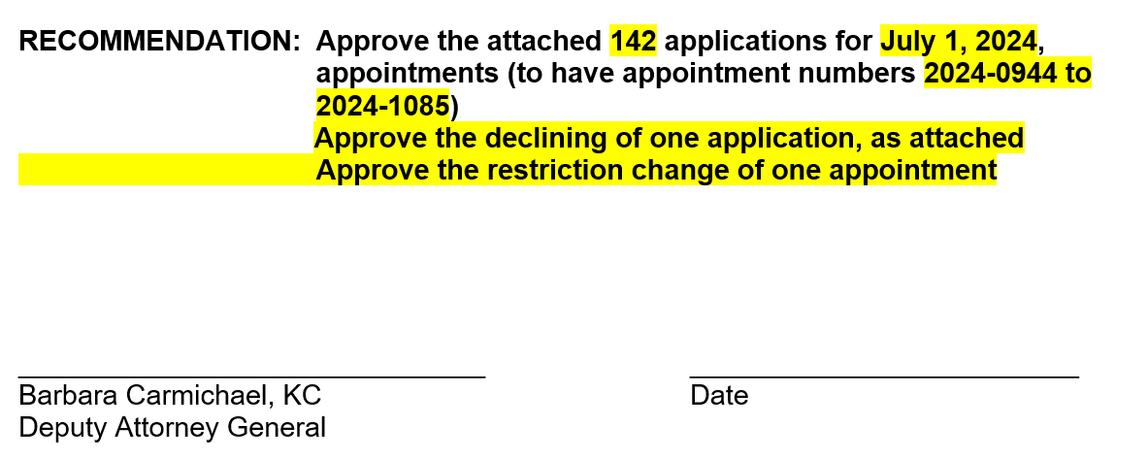

* 1. N – Unsigned do not approve any of the above

1. Always included in the DBN is the **Summary Report** that is generated by the database. The report currently doesn’t include declines (this would be declines in the appointment status field?)